**Links for datasets for Data Vis CW:**

Covid declared pandemic on 11th March 2020 and still runs.

UK lockdowns were in place from:

<https://commonslibrary.parliament.uk/research-briefings/cbp-9068/>

<https://www.instituteforgovernment.org.uk/sites/default/files/timeline-lockdown-web.pdf>

<https://www.instituteforgovernment.org.uk/charts/uk-government-coronavirus-lockdowns>

<https://www.gov.uk/government/statistics/police-recorded-crime-open-data-tables>

<https://www.ons.gov.uk/peoplepopulationandcommunity/crimeandjustice/datasets/recordedcrimedatabycommunitysafetypartnershiparea>

Crime in England and Wales: Other related tables

<https://www.ons.gov.uk/peoplepopulationandcommunity/crimeandjustice/datasets/crimeinenglandandwalesotherrelatedtables>

Coronavirus and crime in England and Wales – Aug20

<https://www.ons.gov.uk/peoplepopulationandcommunity/crimeandjustice/datasets/coronavirusandcrimeinenglandandwalesappendixtables>

Use beautifulsoup to scrape the crime value indexes for European countries over the last 9-10 years.

We can use this data to visualise a geographical heat map for current year

But also a line graph with all countries over the last 10 years

<https://www.numbeo.com/crime/rankings_by_country.jsp?title=2017&region=150>

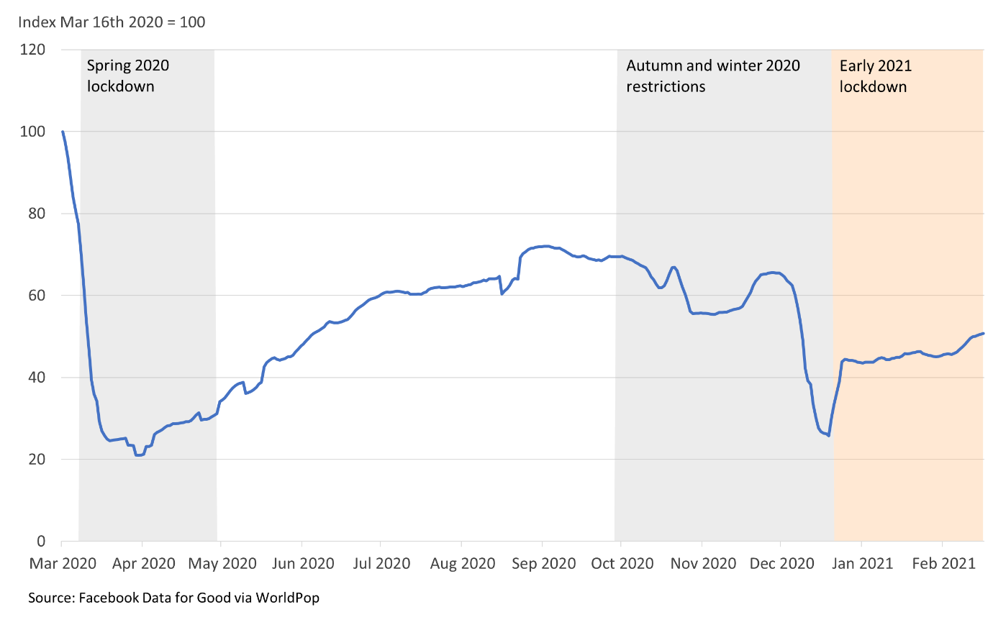

<https://data.police.uk/data/fetch/f78c1c2b-0fbd-4ece-844f-1db8492515f6/>